**DEPARTMENT OF CONTINUING PROFESSIONAL DEVELOPMENT, PROJECTS AND RESEARCH**

**LEGAL COMPLIANCE AUDITS FOR STATE CORPORATIONS**

**(26th February to 2nd March 2018)**

**KSH 104,400/= (DAY DELEGATES covers Course fees course material, meals refreshments and conference facilities)**

**NAIVASHA[1]**

**ABOUT CUEA**

The Catholic University of Eastern Africa (CUEA) is a private university accredited by the Commission for University Education. CUEA’s vision is to be a world class University producing transformative leaders for Church and Society. CUEA’s mission is to promote excellence in research, teaching and community service by preparing morally upright leaders based on the intellectual tradition of the Catholic Church**.**

**ABOUT CUEA FACULTY OF LAW**

CUEA offers a broad range of courses including an undergraduate degree course in law. The law programme is accredited by the Council of Legal Education.

**ABOUT CUEA CPD**

CUEA is also accredited by the Law Society of Kenya to offer short courses in law to meet the continuing professional development needs of legal professionals and other actors in the legal sector. The short courses are run by a special purpose vehicle styled as CUEA CPD

**ABOUT THE LEGAL COMPLIANCE AUDIT COURSES**

A legal audit is a systematic, objective and impartial examination of the ‘legal health’ of an institution. A legal audit assesses and reports on the levels of legal compliance in an institution and the risks arising there from.

CUEA CPD is pleased to present unique opportunity for current and aspiring legal compliance auditors to interact with an experienced advocate, legal auditor and trainer in the person of Mr. Charles B G Ouma, guest speakers from state corporations as well as fellow professionals in this 5 day intensive Course on legal compliance audits for state corporations.

Participants get a unique platform to explore the subject of Legal Compliance Audits from an experiential perspective, share their personal experiences, identify and debate emerging issues, challenge the conventional wisdom and generate pragmatic solutions in an atmosphere of robust peer review

**BASIC COURSE, ADVANCED LEVEL COURSE AND SENSITIZATION WORKSHOP**

CUEA CPD has three versions of the Legal Compliance Audits Course; ‘Sensitization’, ‘Basic’ and ‘Advanced’ .The sensitization workshop is introductory and exploratory in nature. The Basic Course is a five day Course pretty much similar to the advanced Course but the content is compressed to meet the exigencies of the practitioner who has challenges taking the 10 day advanced level course. The advance level Course is a 10 day extensive course laden with hands-on-practical exercises and in-depth examination of compliance issues in cross-cutting operational areas such as public finance, public procurement, ICT, human resource management, administration, ethics and integrity and Board activities. This is the ‘basic course’

**COURSE OUTCOMES**

At the end of the course, the participant should be able to

1. Explain the place of legal compliance audits in a public institution
2. Determine the scope and components of a legal compliance audit
3. Structure a legal compliance audit process
4. Undertake or oversee a legal compliance audit
5. Evaluate a legal compliance audit report

**WHO SHOULD ATTEND?**

Practicing advocates, in-house counsel, internal audit teams, ISO management representatives and other compliance personnel should find this course relevant and useful.

**FACULTY**

This short and intensive workshop has been designed, developed and will be delivered by Mr. Charles B G Ouma. The course is developed with the practical needs of compliance audit practitioners who are a little challenged for time in mind. Charles brings an extensive experience in conducting legal audits as well as high level interaction with state corporations on compliance issues to bear this course.

Charles is an advocate of the High Court of Kenya of 26 years standing. He is the immediate former Assistant Director Continuing Professional Development Projects and Research at the Kenya School of Law. He is presently the head of department CUEA CPD Projects and Research. Charles specializes in undertaking Legal Compliance Audits and has been directly involved as a consultant in 34 legal compliance audits for state corporations since 2009. In the year 2015, 2016 and 2017, Charles facilitated sessions on ‘Legal Compliance and Statutory Reporting’ in the SCAC induction workshops for board members of state corporations and got favorable reviews from the participants for his understanding of the subject and presentation capabilities. Charles has also been lead faculty in several courses on Legal Compliance Audits conducted by the Kenya School of Law where he has similarly been favorably evaluated by the participants.

**CUEA ALUMNI**

CUEA alumni are entitled to a 10% discount on Course fee

**APPLICATION PROCEDURE**

**Application:**Application forms may be obtained from the **Catholic University of Eastern Africa Langata Campus (Registry)** or downloaded from the [www.cuea.edu.](http://www.cuea.edu.)

Duly completed application forms or confirmation of attendance should be submitted two weeks before the course begins to facilitate adequate pre-course interaction between the course organizers and the participants.

**For Course enquiries please** contact Charles B G Ouma (HOD, CUEA CPD (+254 (0) 713 937 282) (ext 1550 on CUEA numbers) email [charles.ouma@cuea.edu](mailto:charles.ouma@cuea.edu) ,Dr Maurice Ajwang Owuor (Dean Faculty of Law)(1541) or Agnes Ext 1541 and Jacynter Ext 1545 on 020 252 5811-5. You may also email us at [cueacpd@cuea.edu](mailto:cueacpd@cuea.edu) or visit our website: [www.cuea.edu](http://www.cuea.edu)

**Accommodation[2]**

Delegates should make their own travelling and accommodation arrangements. CUEA CPD will however negotiate preferential rates for delegates who wish to stay at the conference venue.

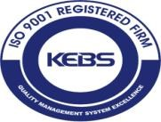

**CUEA is an ISO 9001:2008 Certified Organization**

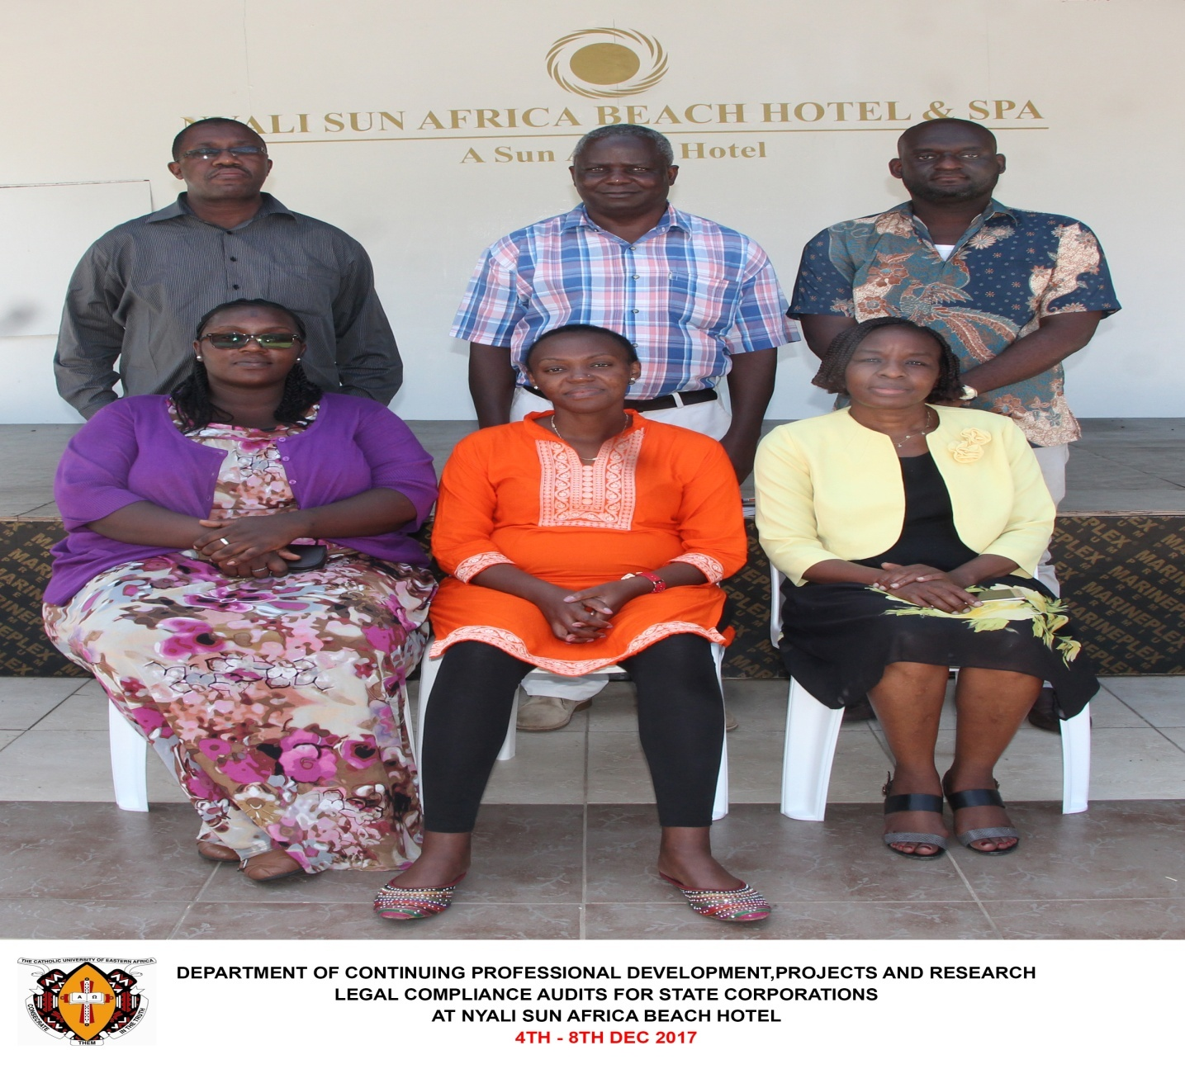

1. The conference venue is a high end hotel in Naivasha easily accessible by public or private transport.
2. The conference venue is a high end hotel in Naivasha easily accessible by public or private transport.